1. jobs: This commands displays all the running and stopped processes.

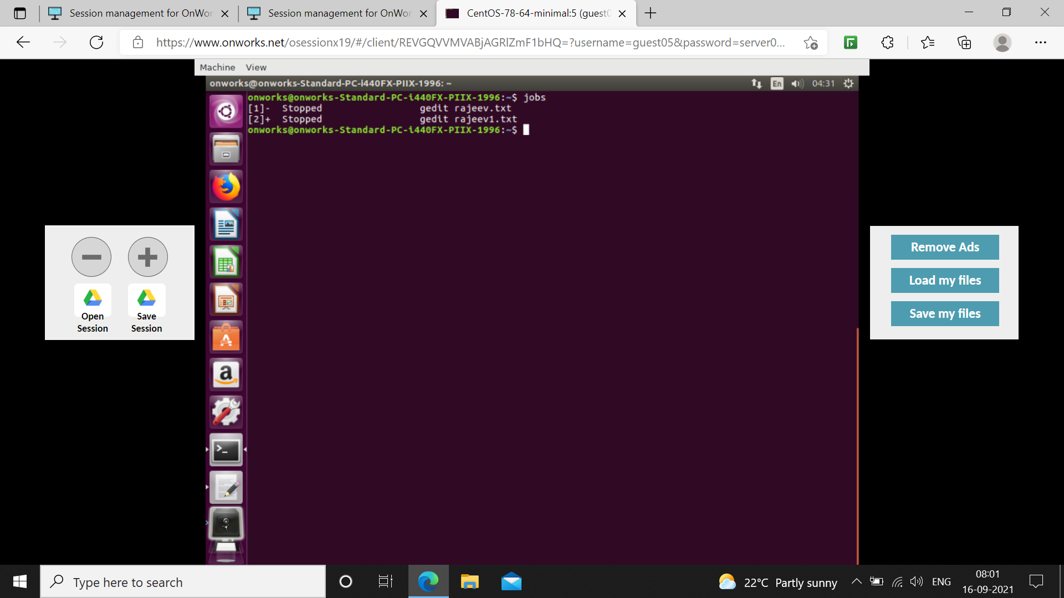

2. fg and bg: These commands use to background processes to foreground and foreground processes to background. fg %n or bg %n, where n is the value of process.

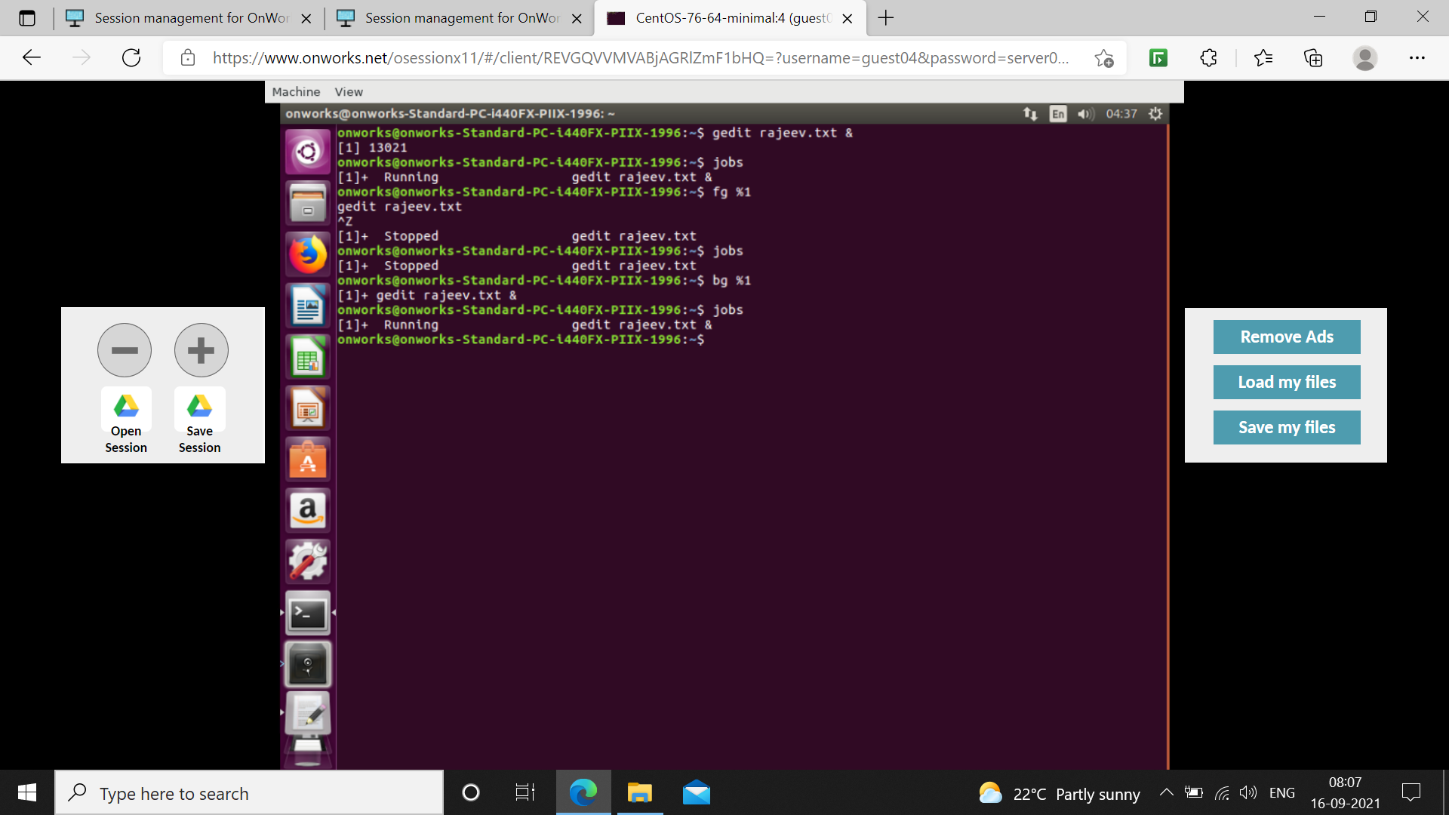

3. less: This command displays content of files and help user to navigate through the contents.

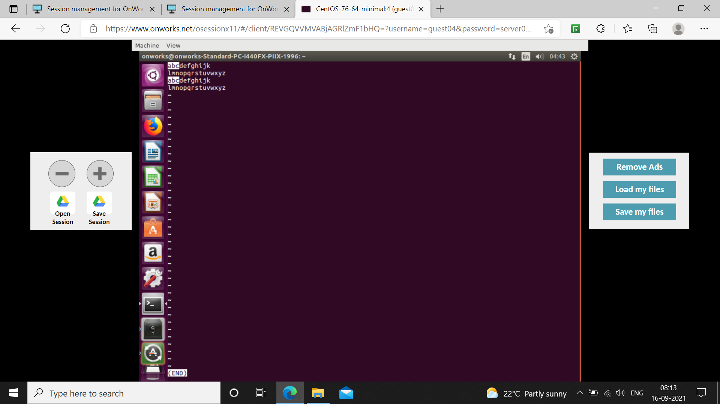

4. tail: This command displays last 10 lines of the files by default. However user can change the number of lines using
tail -n -number filename
where number specifies number of lines.

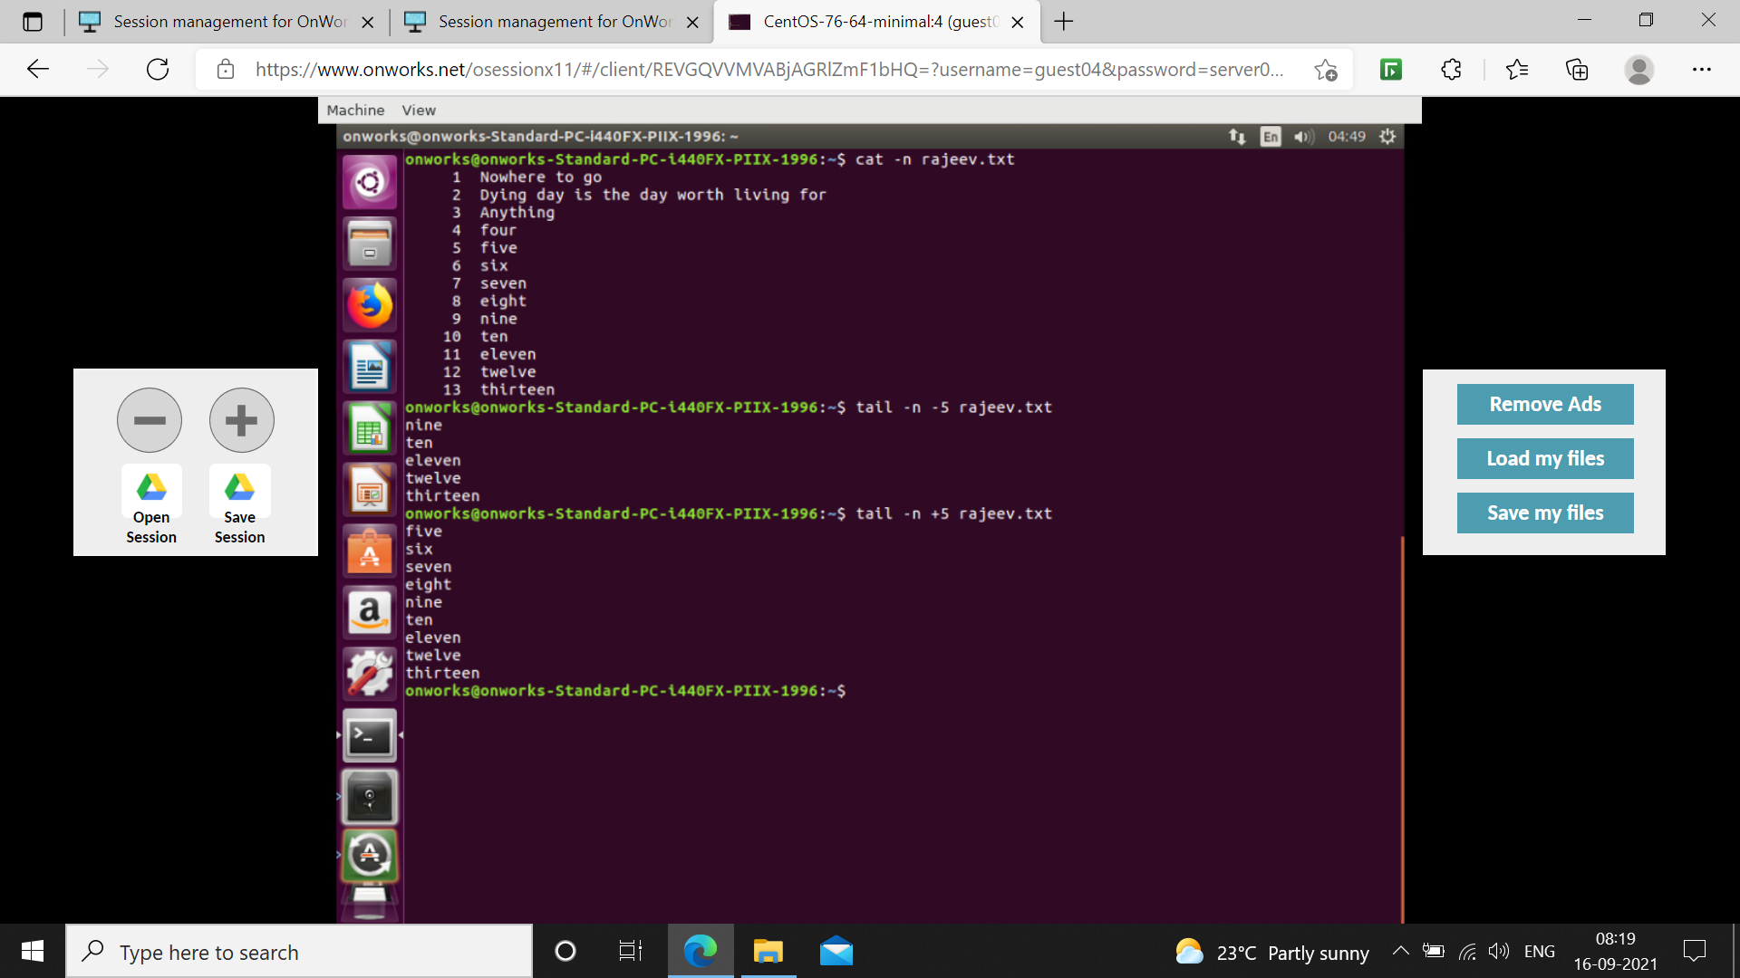

tail -c -n filename:
This option displays character wise.
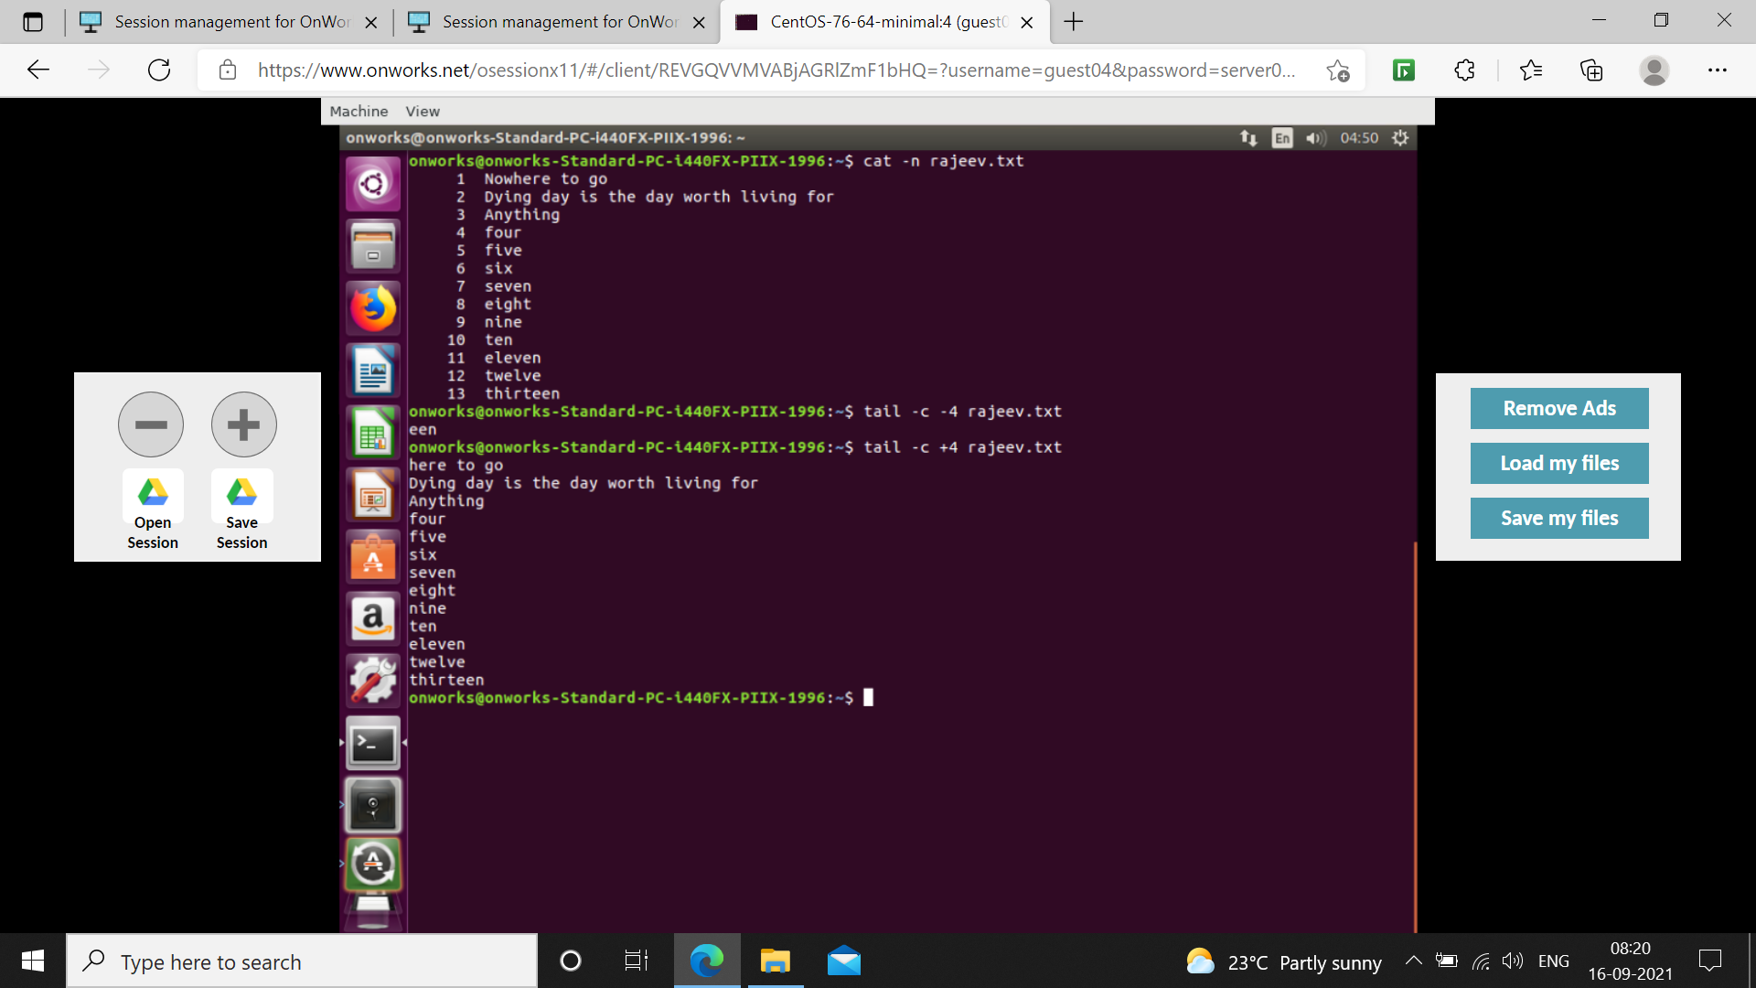

5. head: This command displays first 10 lines of the files and lines can be changed.

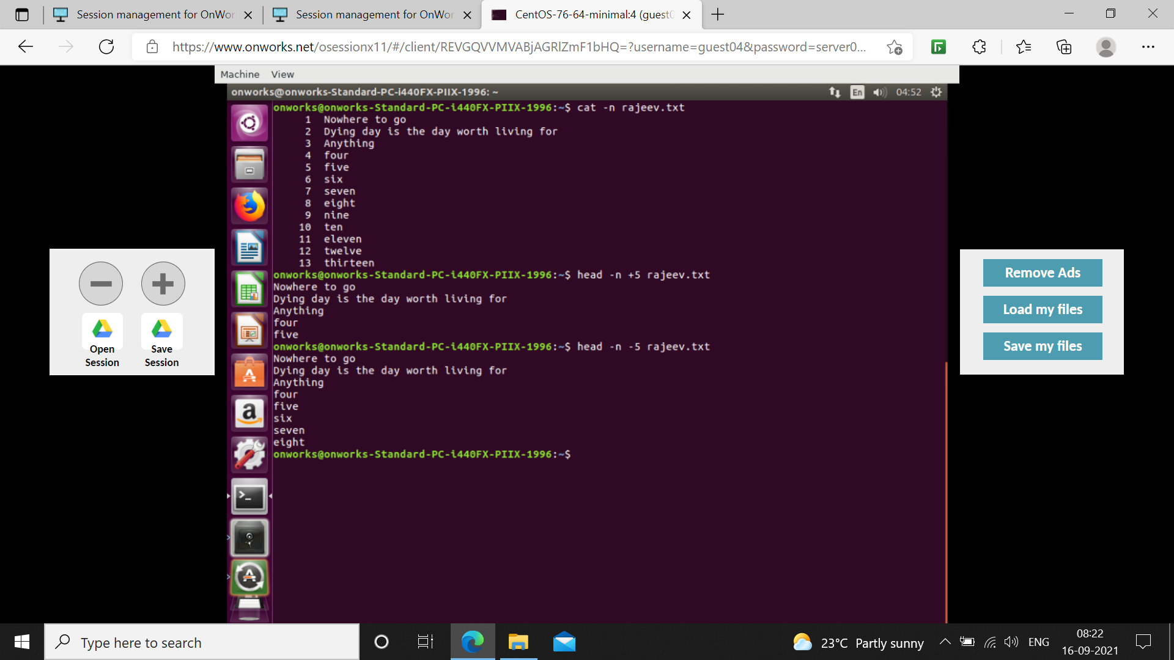

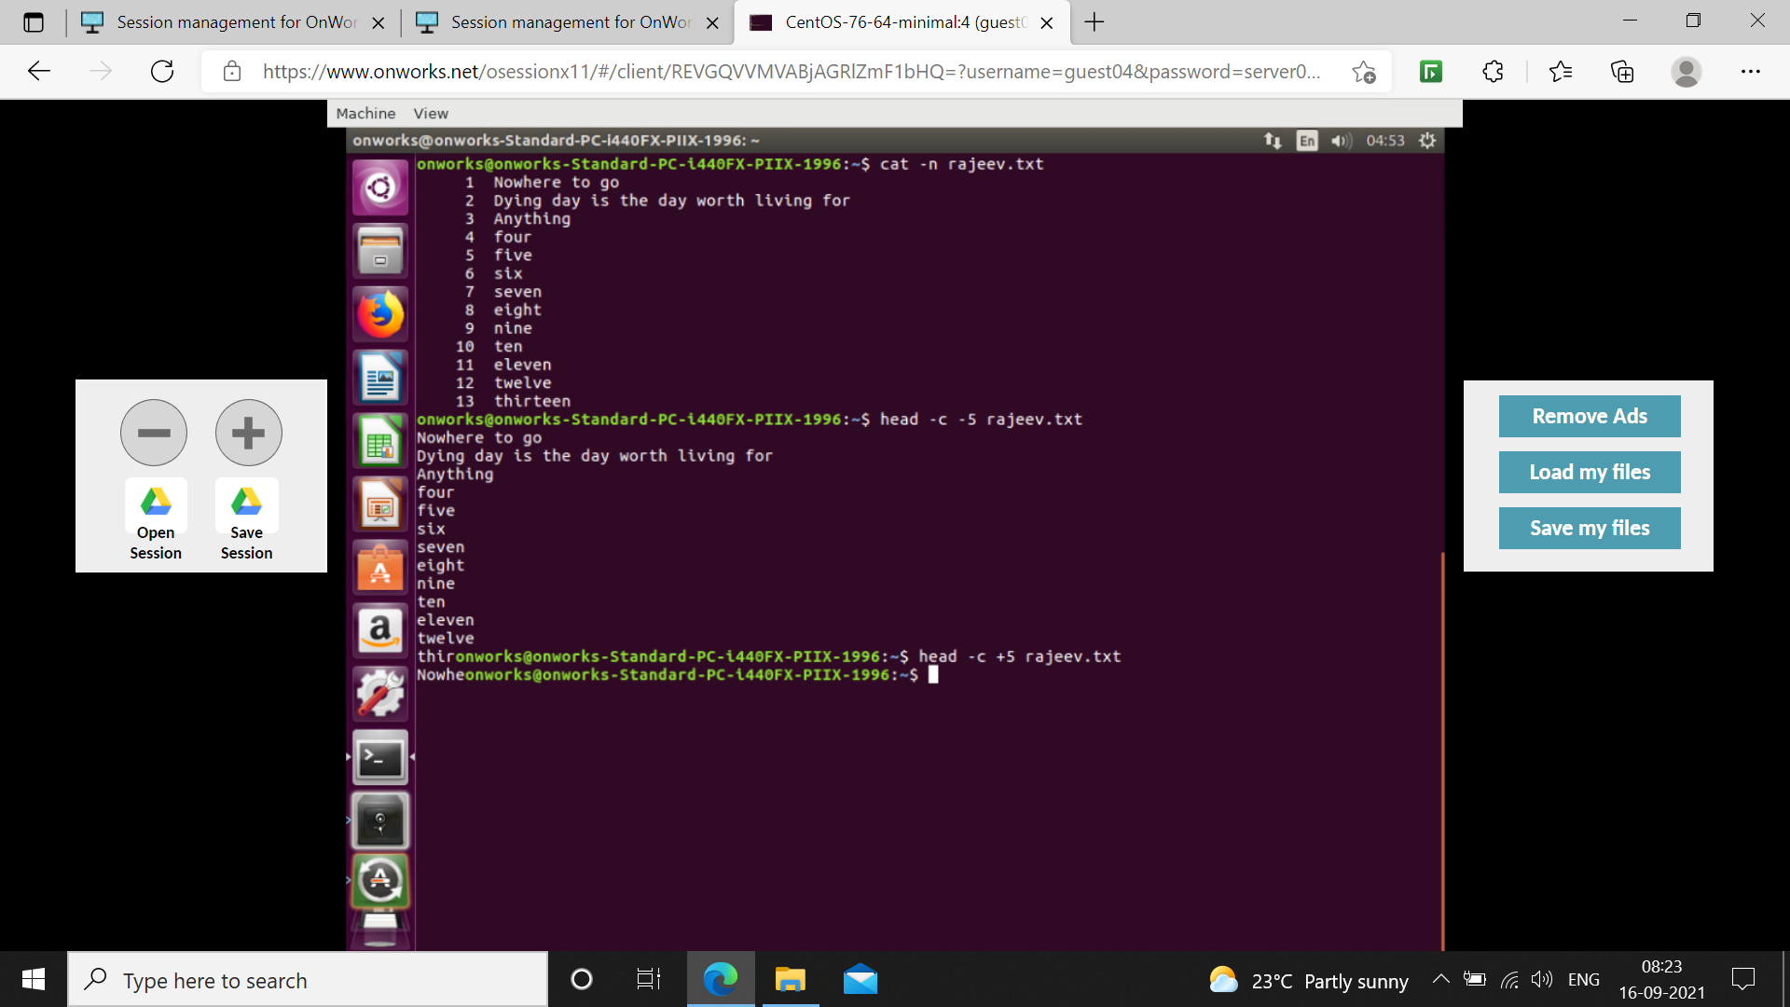

6. tr: This command is used to delete or translate contents of the file.

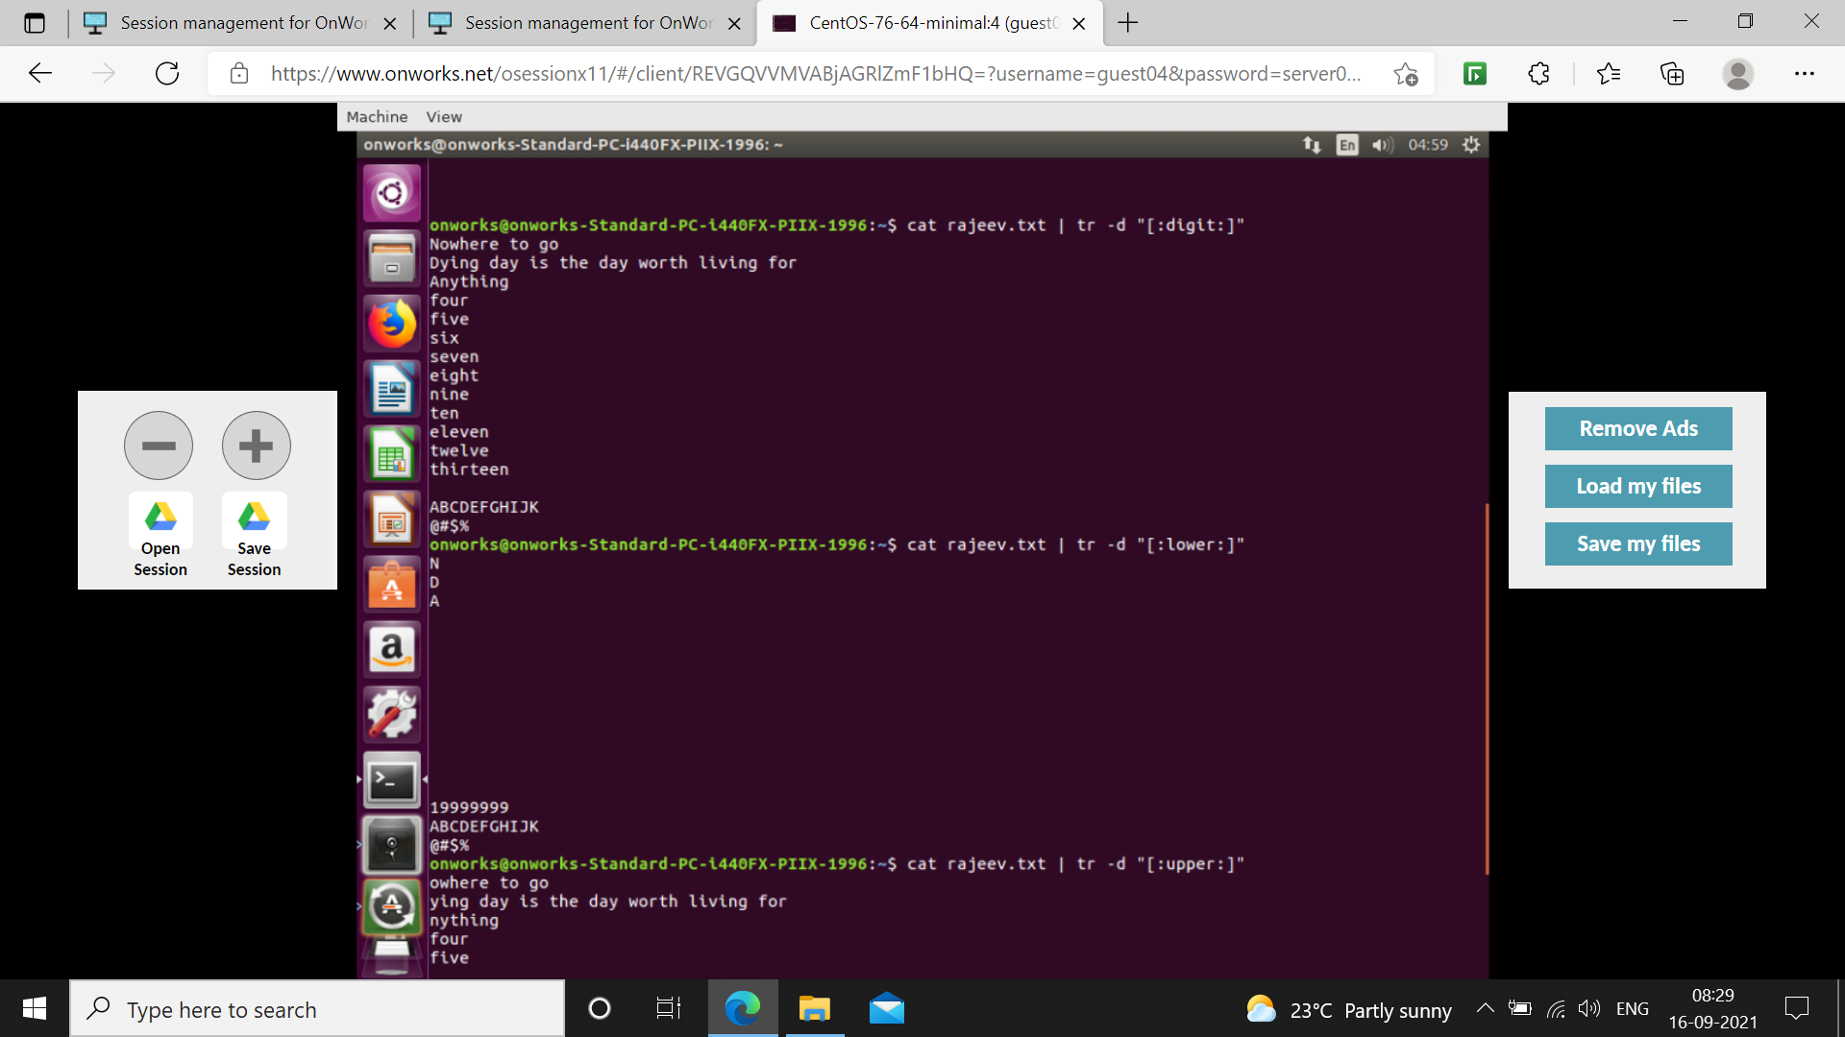

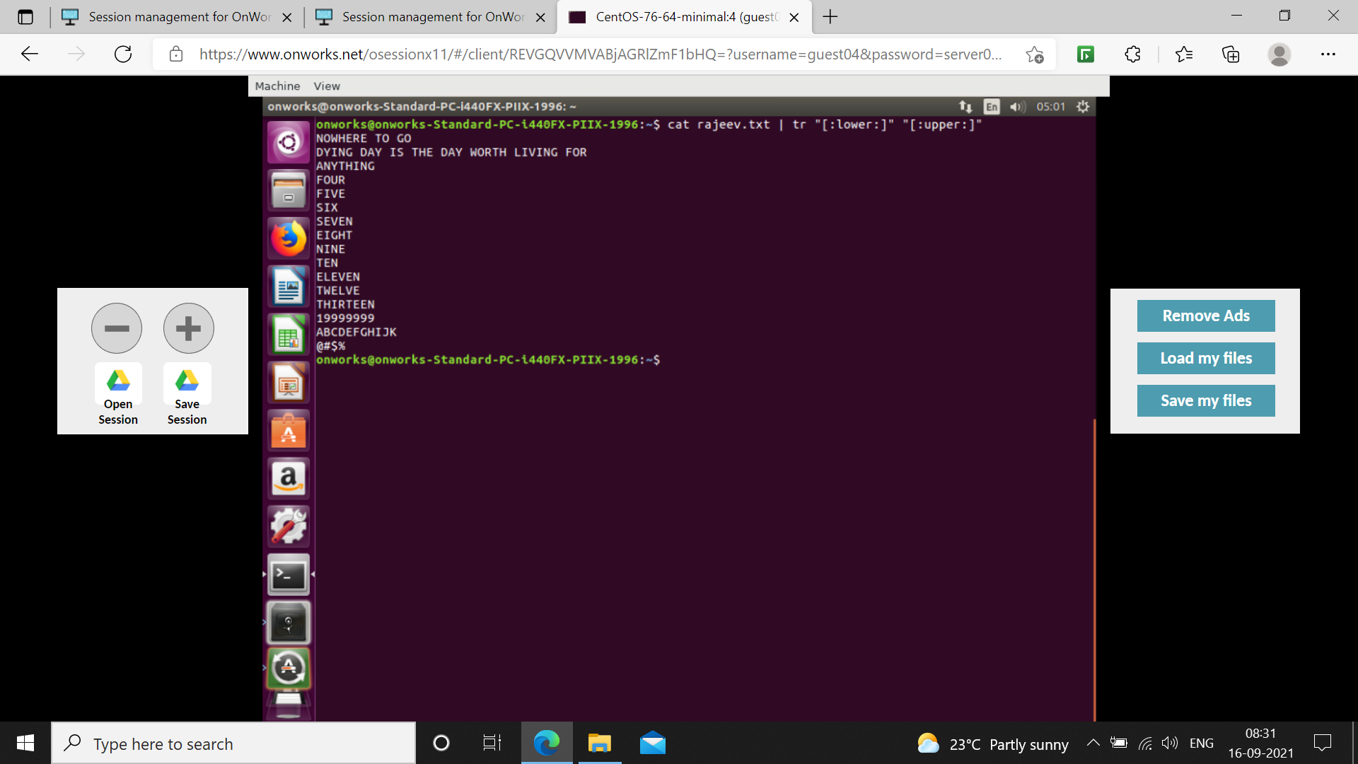

7. awk: This command deletes the recurring digits and characters.

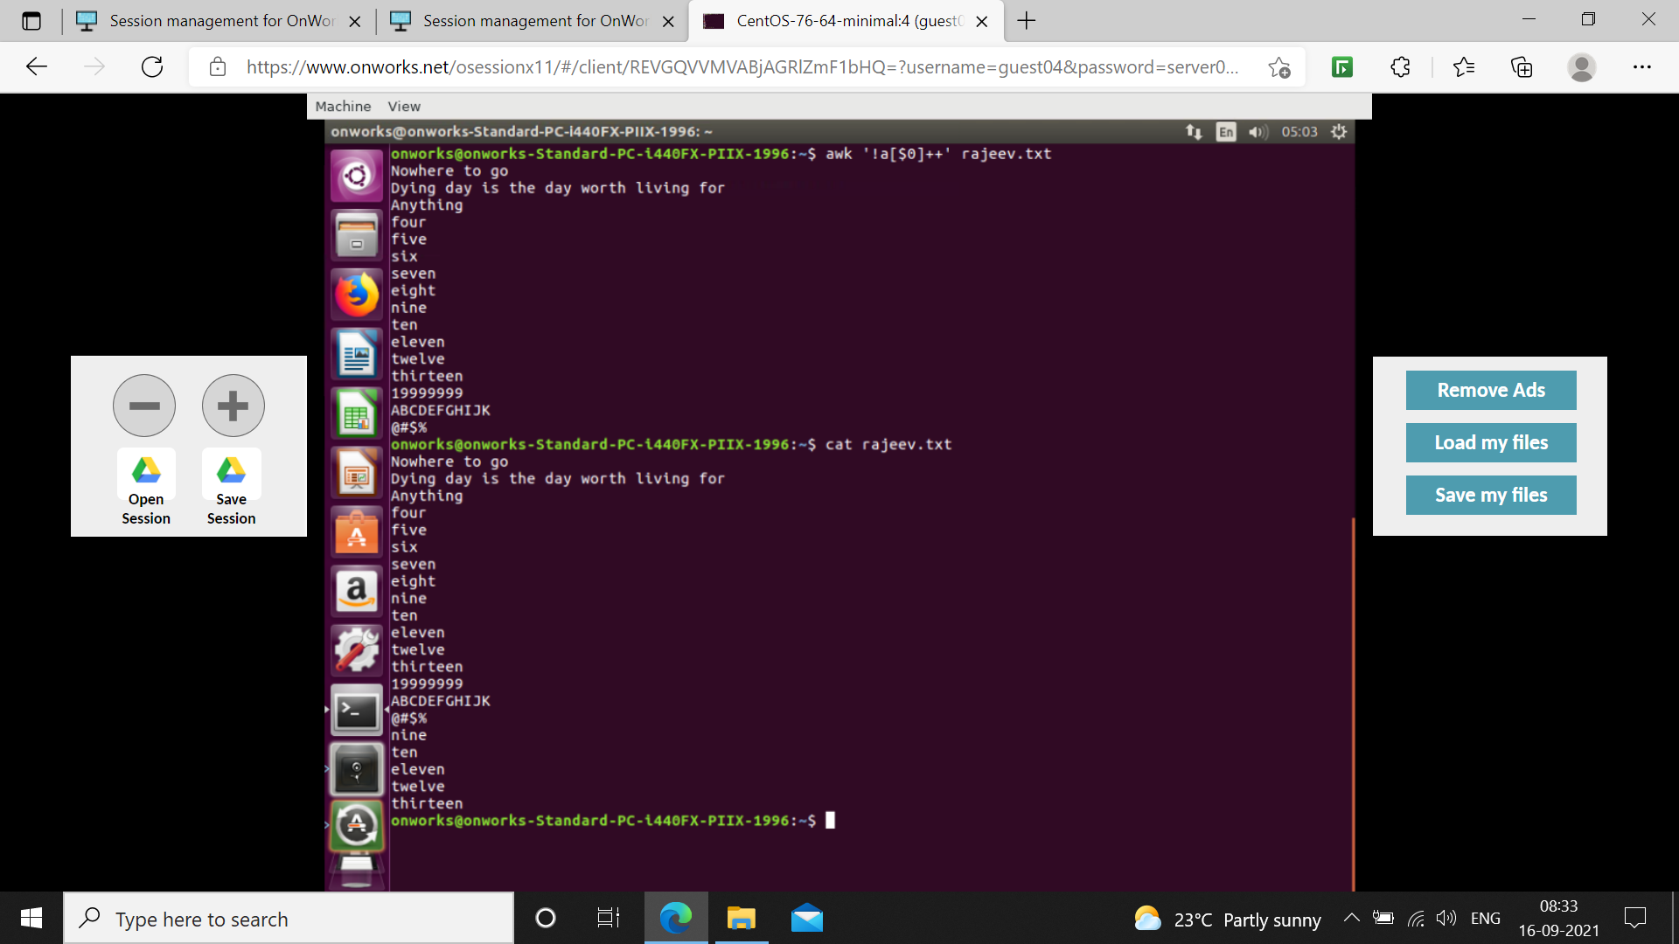

8. tree: This command displays files and directories in tree like structure.

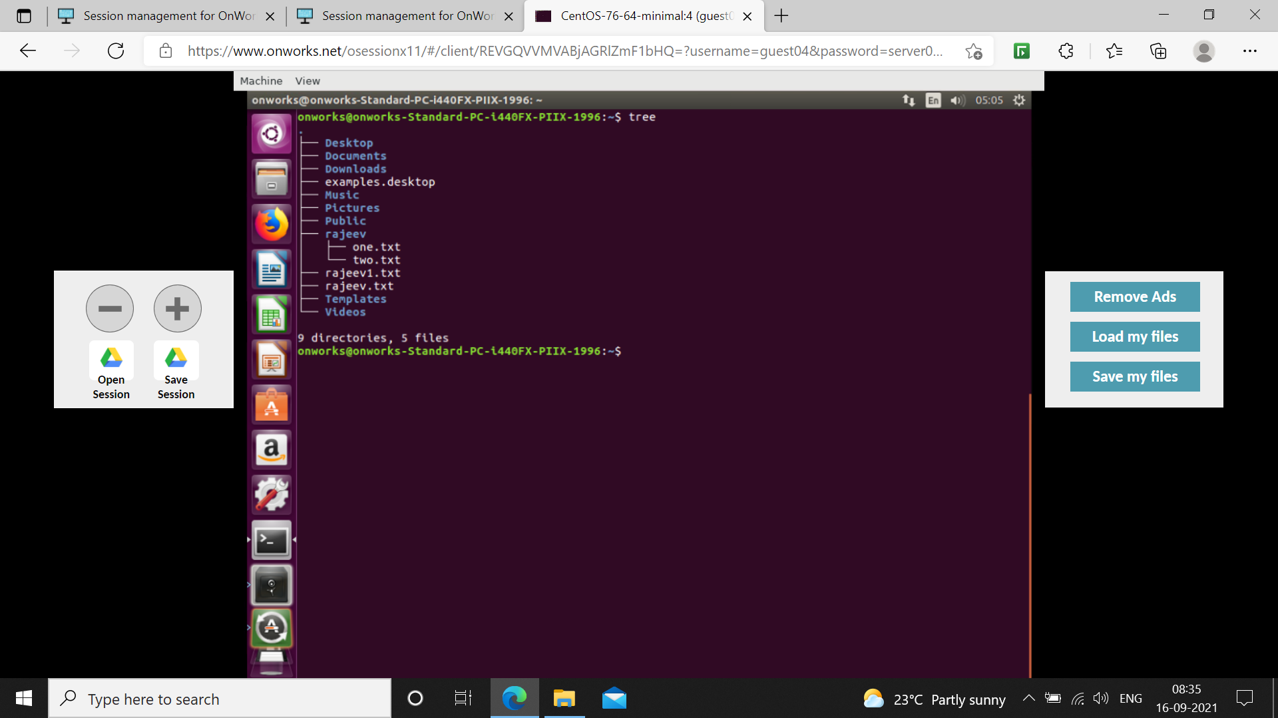

9. find: This command is use to find whether the files are present in the specified path or not and also can delete them with or without user’s conformation.


